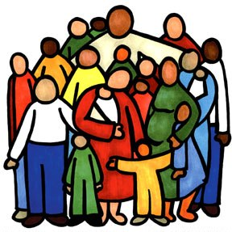
You Belong!

Whether you are a member or not, you belong to Gordon United Church. Your gifts are appreciated and your participation is welcome. The only difference between members and adherents is that there are positions of spiritual leadership that are only open to those who have made a formal commitment to Gordon United, and there are a couple of issues (such as calling a new minister) on which only members are allowed to vote. Otherwise, the measure of belonging is simply presence and participation. If you wish to be part of Gordon United, you are! If you are active in any aspect of congregational life, and especially if you are active in the worshipping community, you belong. (Of course, if you are unable to attend due to ill health, frailty, work commitments, etc, but still wish to stay connected, you, too, belong!)

This being said, we encourage the act of commitment involved in becoming a member. (We might compare it to the difference between living together and marrying.) Those who wish to officially become members can do so in a number of ways:

1) If you are already a member of a United Church, you simply contact your previous church and ask them to transfer your membership here.
2) If you are a member of a church of another denomination, the same applies.
3) If you have been active in another church but don’t know where your membership lies, we will simply adapt the process.
4) If you are a new Christian you will be asked to make an Adult Affirmation of Faith (Confirmation), and if you have not been baptized, to participate in the sacrament of Baptism.
In all cases except the first, and especially if you are a new Christian, you will be asked to take some time to get to know the beliefs and practices of the United Church of Canada. This is normally done through Confirmation classes (“United Church 101”). All new members are asked to participate in a brief act of worship during regular Sunday services to mark their commitment.

If you have any questions, or are interested in becoming a member, please call or email Rev. Heidi.

